**ICTWEB431 Assessment Task 1**

**Part C: Website Testing Log**

**Part C: Website Testing Log**

|  |  |  |  |
| --- | --- | --- | --- |
| **Date** | **Test Type** | **Result** | **Recommended Actions** |
| 22/03/2024 | W3 HTML Validator | 8 Errors | Add language to <Html>  Add a title  Remove space from contact us.  Rearrange my tags  And remove space from copyright |
| 22/03/2024 | W3 CSS Validator | No Errors |  |
| 22/03/2024 | Cross-browser compatibility | No Errors |  |
| 22/03/2024 | Responsive design | No Errors |  |
| 22/03/2024 | Accessibility | 2 Errors | Put in page ‘Title and change product alt description from ‘Table’ to something more detailed |
|  |  |  |  |
|  |  |  |  |
|  |  |  |  |
|  |  |  |  |
|  |  |  |  |

W3 HTML Validator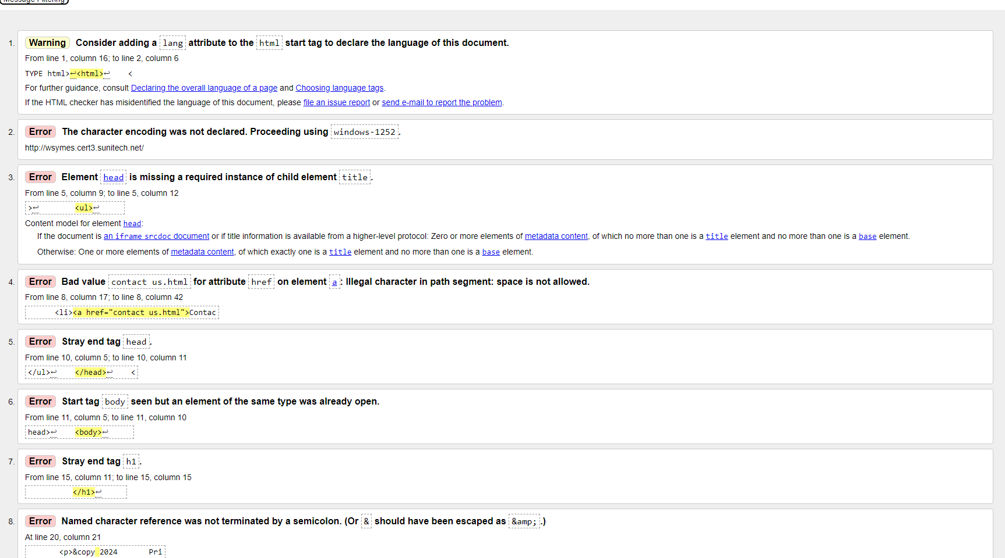

Errors Resolved

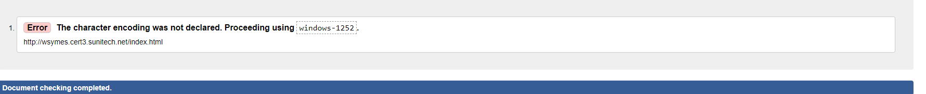

W3 CSS Validator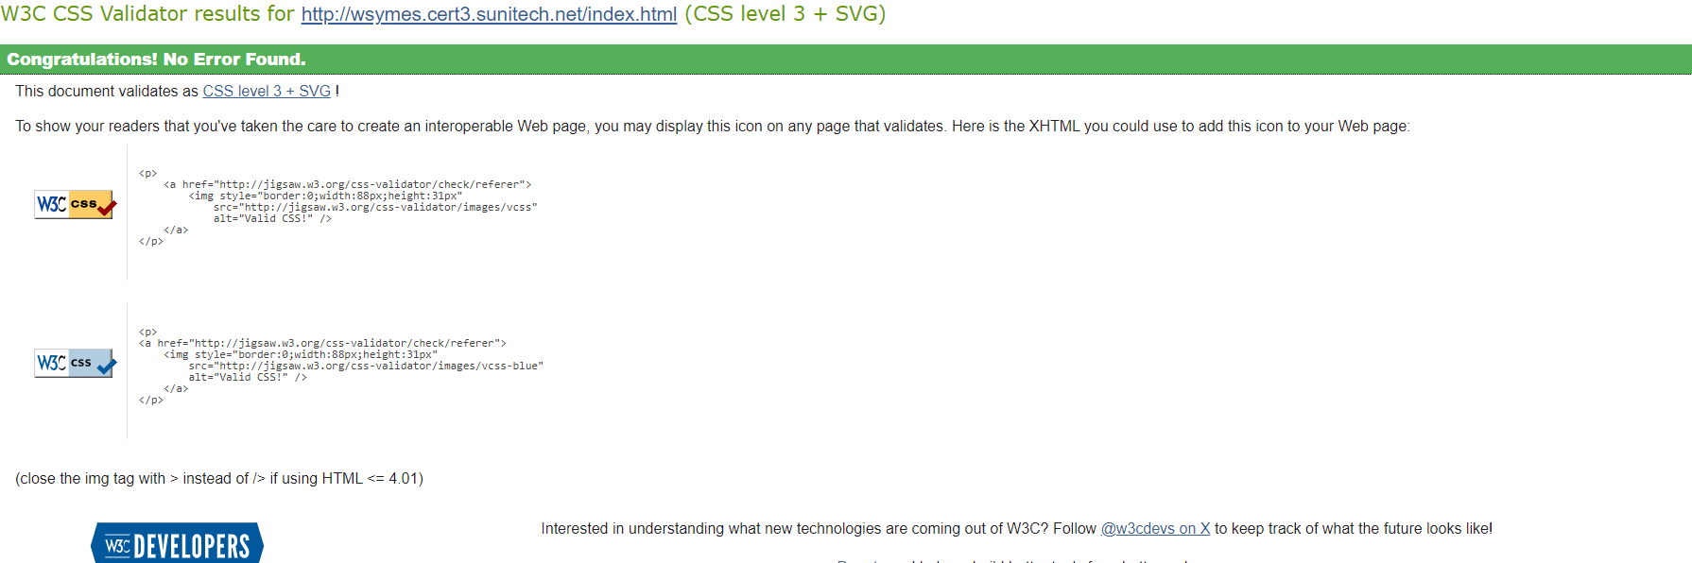

Responsive design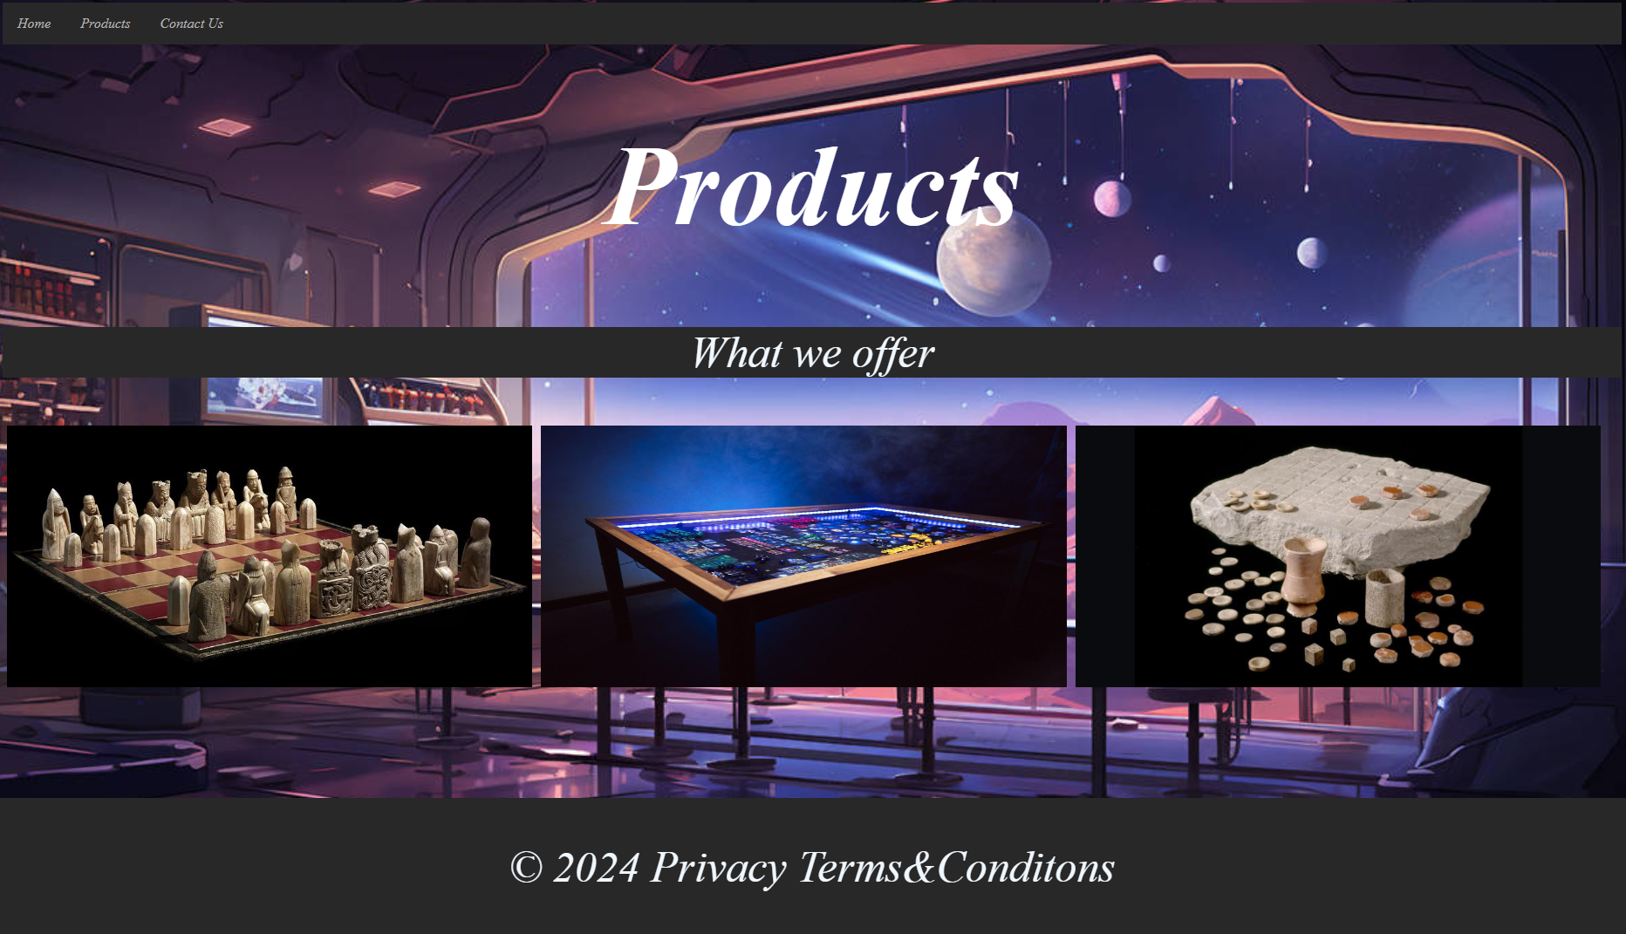



Accessibility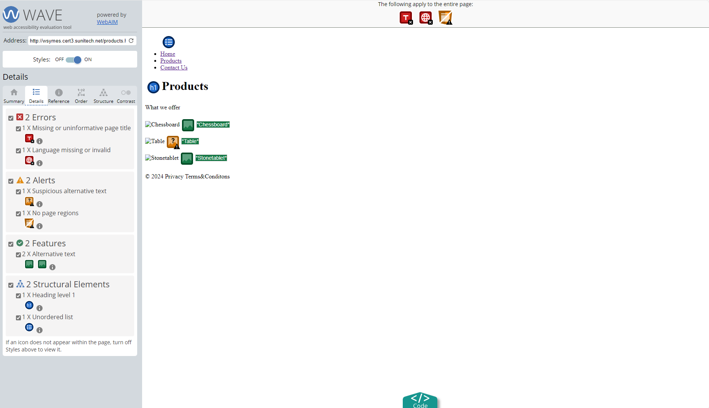

No Errors

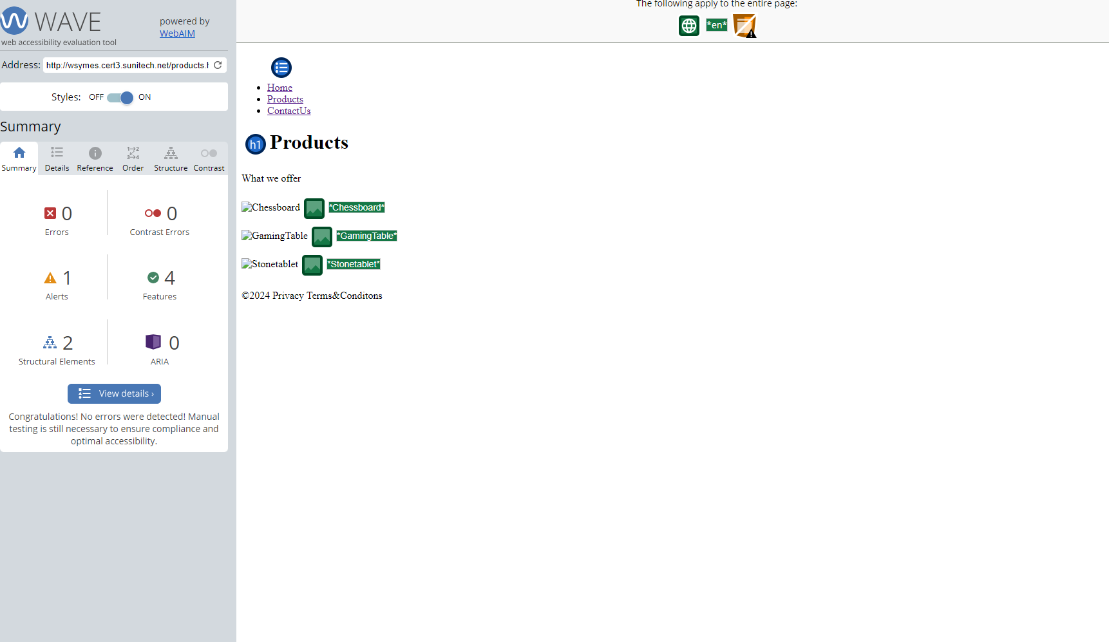

Cross browser compatibility

